Assembling a Titan Machine

Step 1: Remove all packing from the machine including shrink wrap, straps, and wood used to secure everything down when the machine was shipped.
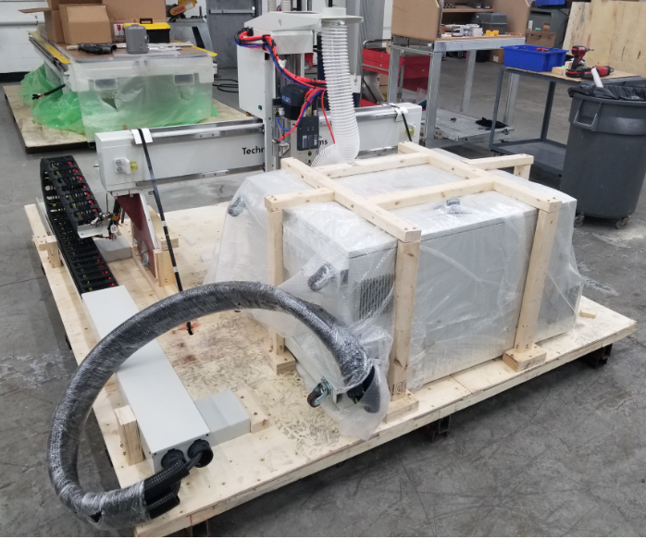

Step 2: Take the two white brackets shown and attach them to the base of the machine on the left hand side. The screws will be shipped with them or already attached to where the brackets needs to be.
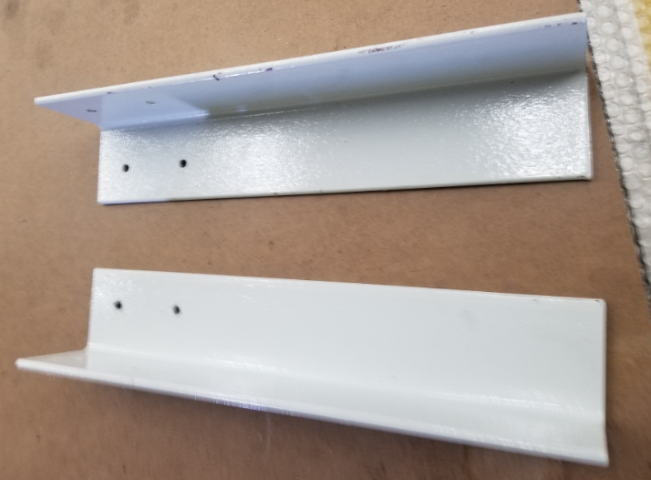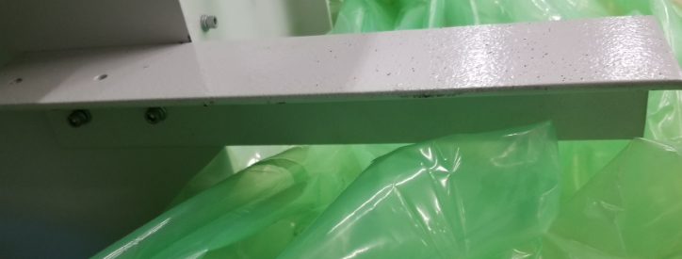
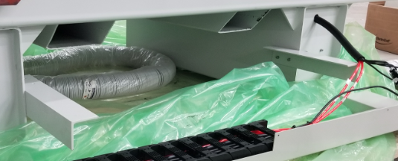

Step 3: Remove the aluminum t-slots and yellow guard rails on the left and right side of the machine as shown. Mark them and store them properly so that way they can be easily put back into place once the gantry is installed.
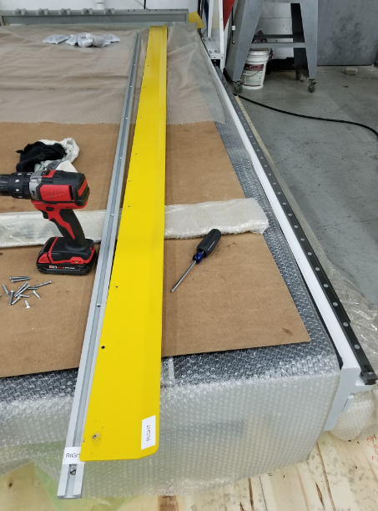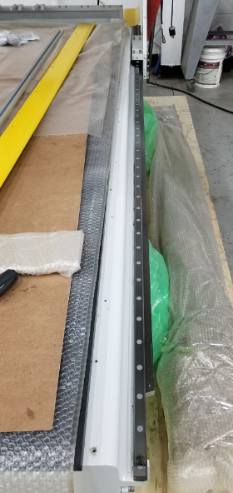

Step 4: Remove the red brackets on both sides of the machine so that way the bearings can be moved around when the gantry is ready to be placed into position.
**** DO NOT slide the bearings off the rails. They need to stay on when the gantry is assembled.
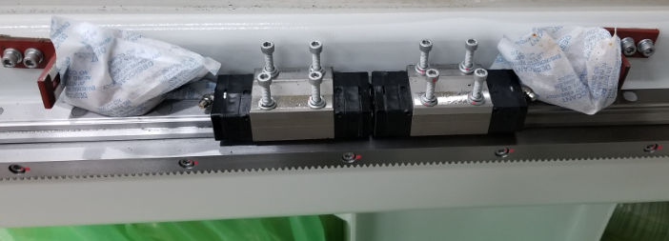

Step 5: Take the controller off the pallet and put it to the side where the cable carrier is located. Take a forklift and place it under the gantry as show.
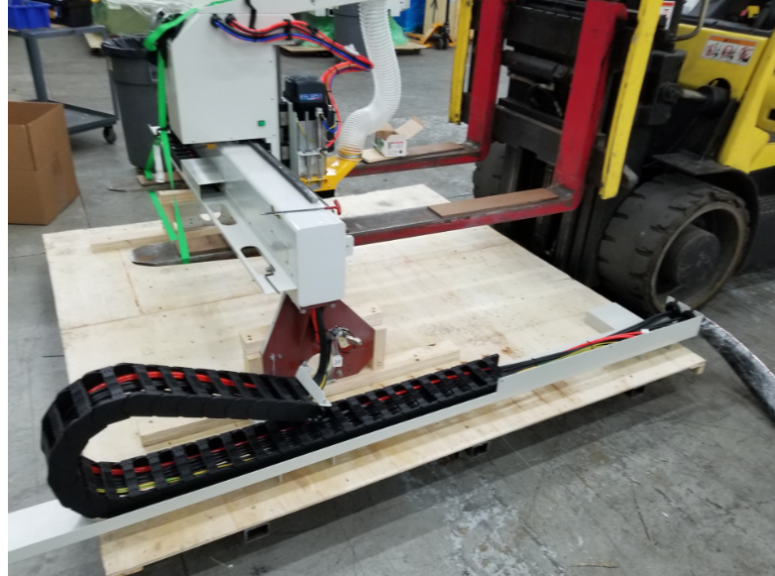

Step 6: Make sure to strap the gantry to the forklifts as shown in order to prevent the gantry from tipping when it is being moved.
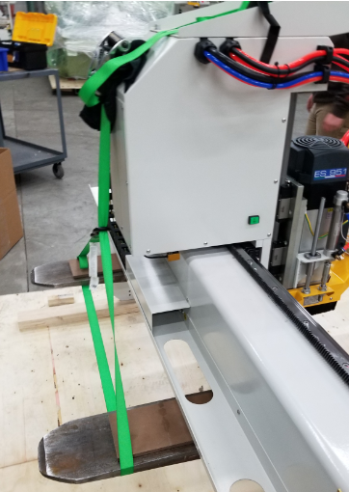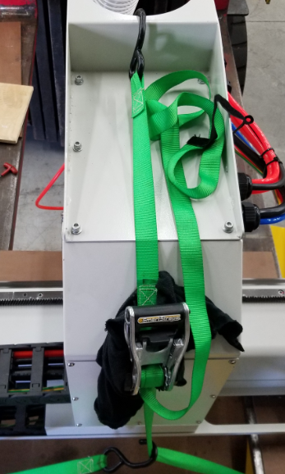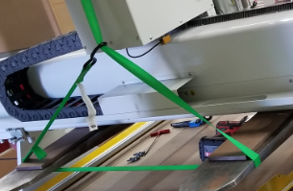

Step 7: Place the cable carrier behind the pallet as shown. It needs to be as close to the left side of the machine as possible. When lifting the gantry up using the forklift, make sure to lift it high in order to go above the base of the machine so that way the gantry can be placed steadily on top of the bearings.
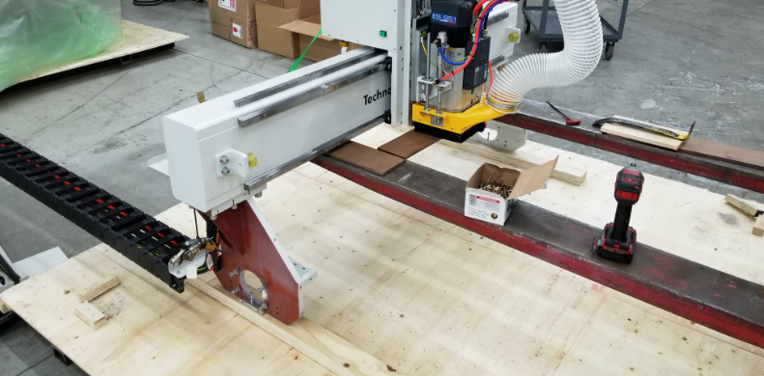

Step 8: Lift the gantry off its pallet and pull the pallet out of the way. Move the forklift forward towards the machine and place it on top of the bearings as shown. Make sure to get one bearing lined up at a time and to get four screws threaded into each bearing, but to not tighten them down until all the bearings have four screws in each of them. Also, someone needs to pull the cable carrier and the controller box with the gantry as it gets put into place.

**** DO NOT slide the bearings off the rails. They need to stay on when the gantry is assembled.

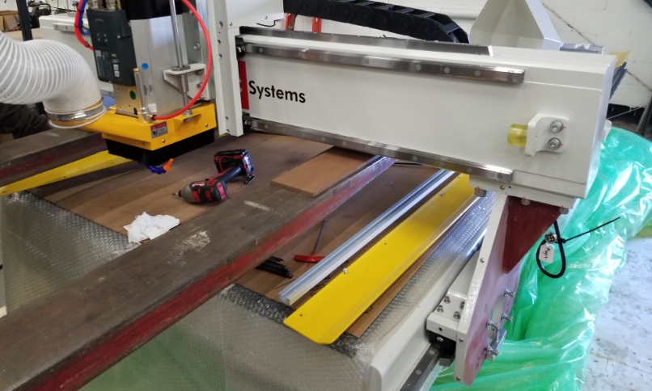
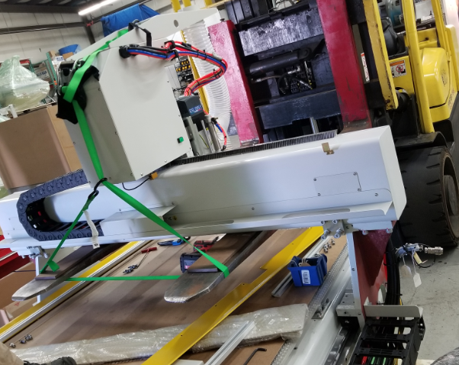
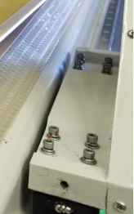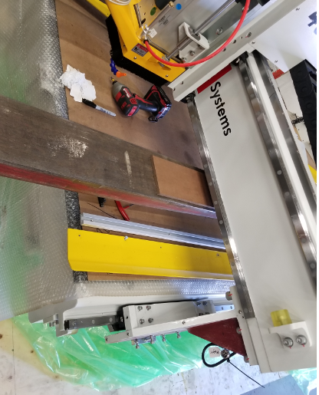

Step 9: Place the cable carrier onto the white brackets that were installed on the machine in step 2 and use the screws already in place to secure it. Connect all wiring and hoses coming from the base of the machine to the cable carrier. Connect all wiring and hoses coming from the base of the machine to the cable carrier.
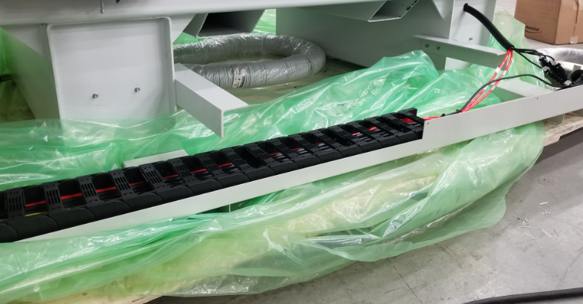
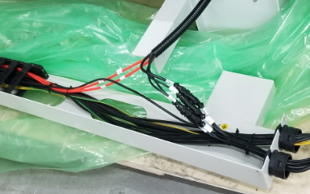

Step 10: Place the gray bump stops that are packed with the machine and install them on their respective uprights as shown.
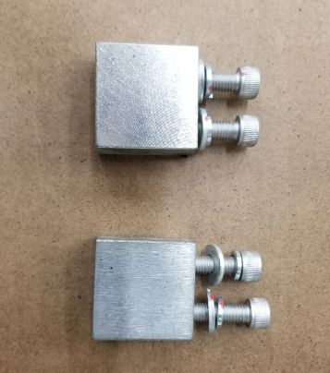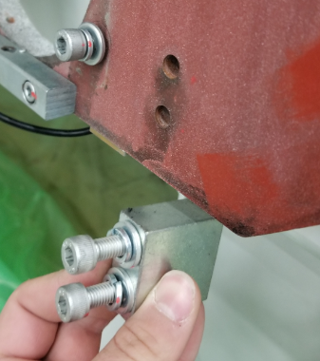
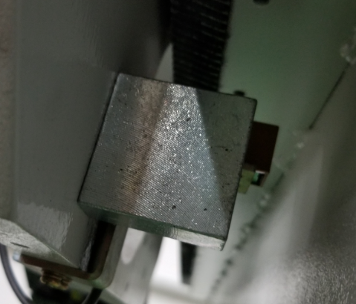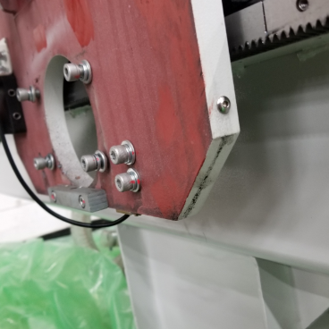

Step 11: Place the homing switch on the left side of the machine on its upright as shown with the screws that were shipped with or that are already in place.
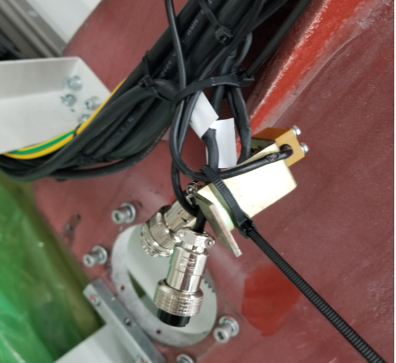
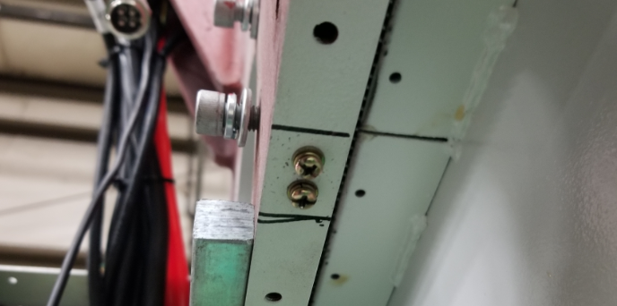

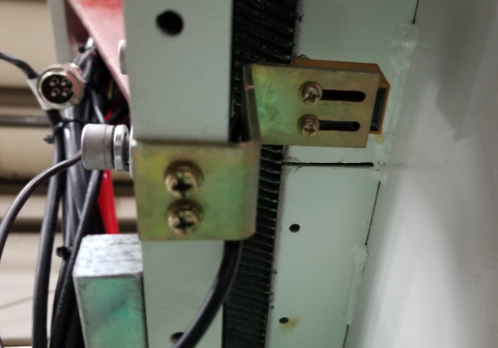

Step 12: Pull the gantry all the way forward to its bump stops. Mount the motors in their respective spots according to their labeling and using the 4 bolts that are already in place and the one set screw that came packed with the machine. Make sure the motor meshes properly into the rack and pinion to avoid any kind of backlash. You can check for play once the machine is fully assembled and powered on.

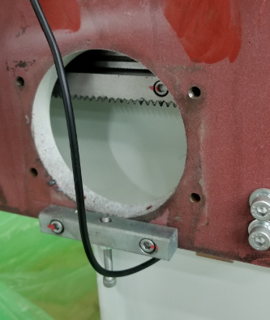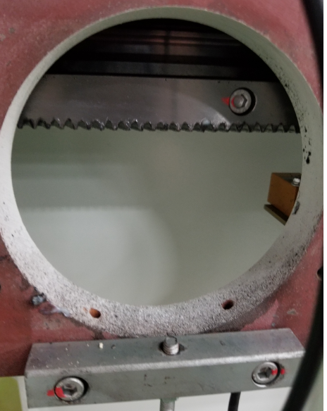

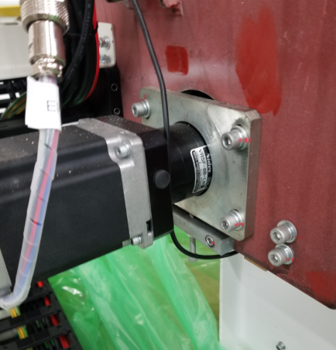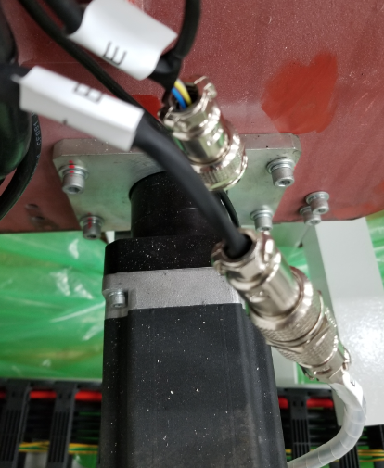

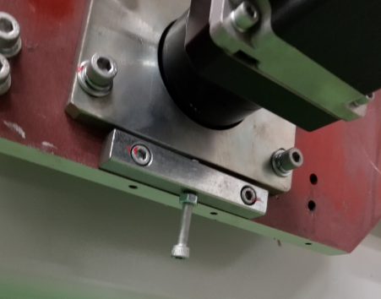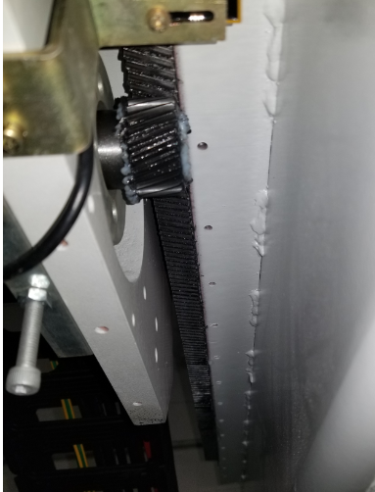

Step 13: Mount the covers onto the machine and make sure the cover that has the tool touch off puck is plugged in before it is completely screwed in.
