How to Use all 6 Work Coordinates on the Weihong Controller
This controller allows a user to have up to 6 work coordinates saved at a time. They are labeled as G54, G55, G56, G57, G58, and G59. The controller should be automatically set for G54 (work coordinate system 1) because next to X, Y and Z on the main screen should be a number 1. In order for the controller to use another coordinate system like G55 (work coordinate system 2), there needs to be a different number next to X, Y, and Z, such as 2 to 6. In order to change between each coordinate system go to the Main Menu, then go to the 3.Operations, then go to 6.Select WCS.
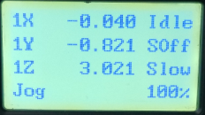
From the Main Screen press the Main Menu button
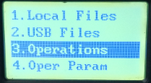
Next, scroll to 3.Operations and press OK to enter
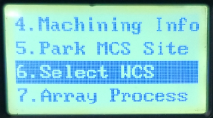
Next, scroll to 6.Select WCS and press OK to enter
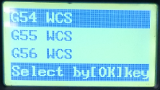
Scroll through each of the WCS and press OK to the work coordinate system that needs to be used.

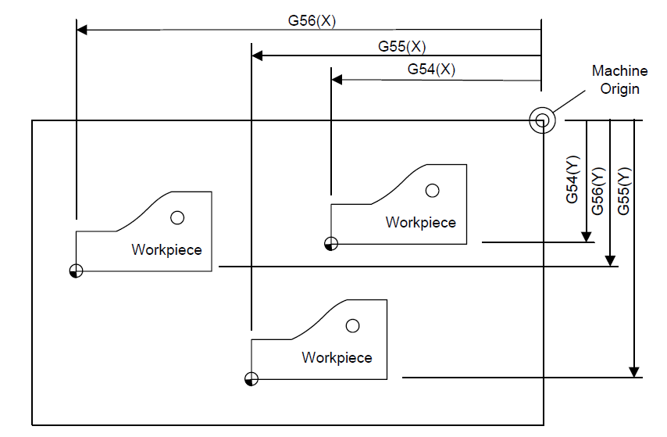
Labeled here is the multiple work coordinate origins that can be saved for certain parts or fixtures. G54 represents Origin 1, G55 represents Origin 2, and G56 represents origin 3.

