How to Use the Select Line Number Function on the Weihong Controller
A file that is currently loaded to the machine may be ran using only certain line numbers of the G-Code if the operator chooses to do so. Also, if a bit breaks during a long file, this function can be used to avoid from having to start the file from the beginning. This can be done by using the select line number function on the controller.
First, go to the Main Menu, then go to the 3.Operations, then go to 3.Select Line No., and then type in the corresponding line numbers you would like to start and top at.

****Before hitting Execute Now, make sure the spindle is turned ON

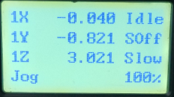
From the Main Screen press the Main Menu button
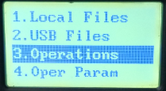
Next, scroll to 3.Operations and press OK to enter
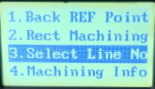
Next, scroll to 3.Select Line No. and press OK to enter
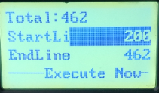
Go to the Start Line and End Line and enter in where you would like to start and end the file. The End Line will automatically be set as the last line in the G-Code unless you decide to change it.
Scroll down to Execute Now and press OK for the file to run from the Start Line to the End Line.
****Before hitting Execute Now, make sure the spindle is turned ON
