How to Wire Safety Enclosure to the Weihong Controller

For Play/Pause limit switch: You need to wire Comm from the limit switch to 0V and NO (normally open) from the limit switch to GX10. The wires will be labeled as GX10 and 0V respectively.
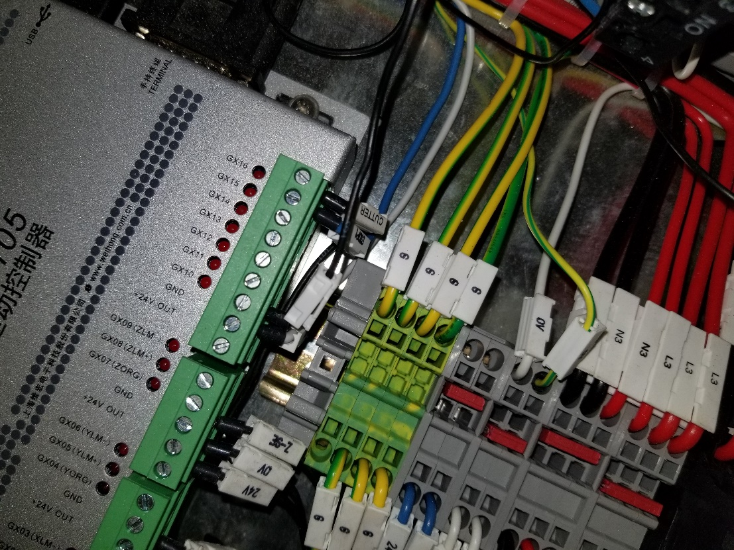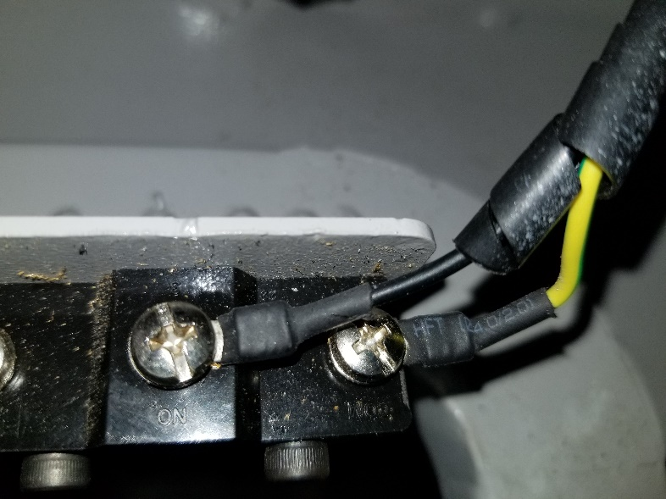
For E-stop: You need to connect One End of the E-stop to the top of the Off Button and the other end to the top of the main E-stop. The wires will be labeled as E-stop and off button respectively. Make sure there is no jumper wire going from the off button to the main E-stop button. If there is, then it will bypass the Estop on the front of the enclosure.
