How to use Laser Pointer as Work Offset for your Origin on Weihong Controller
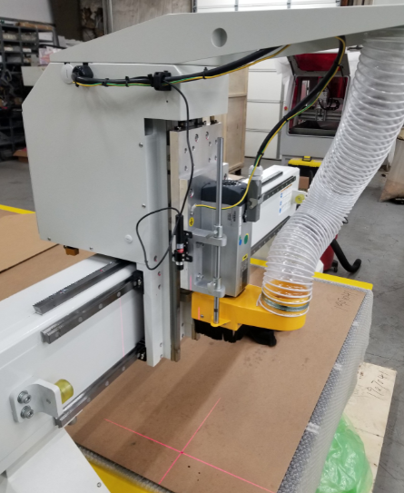
******Make sure the laser pointer is straight on your machine. If the laser pointer is not straight, then moving the Z-Axis will cause the red laser point to shift. If it does shift, then the offset to your origin may be off when setting X and Y origins.

First, mark a point on the bed of your machine to use as a reference point for finding this offset.
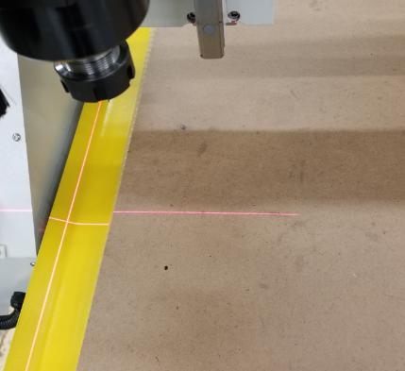

Next, send the laser pointer to the mark you made on the table using jog and step mode on the handheld.
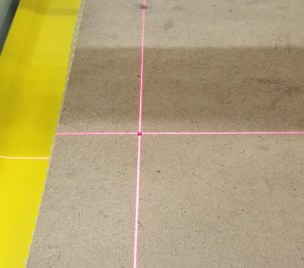

Press the XY=0 button on your handheld to save this as the XY origin for right now. The X and Y coordinates on the handheld should now read 0. Notice that there is a number 1 next to the X and Y indicating we can see the Work Coordinate System.
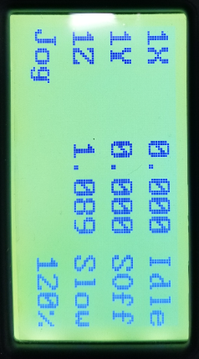

Place a centered bit, such a v-bit, or something that has a defined tip into the spindle in order to get the best accuracy.
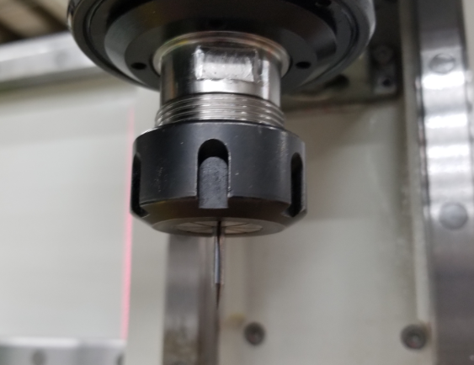

Using step and jog mode with your handheld, move the bit onto the top of the spot you marked. Do this carefully and step with small increments in order to avoid hitting the machine bed or possibly moving the mark from its original spot.
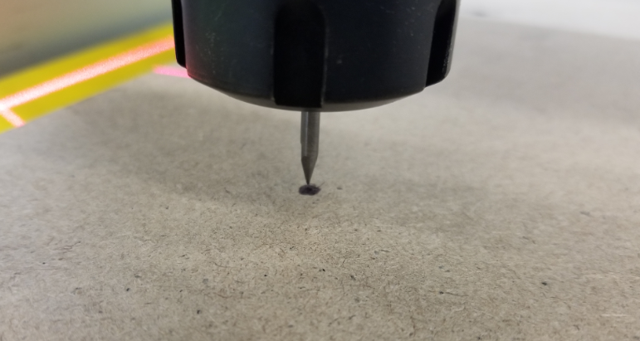

With the bit now placed on the top of the mark, take note of the coordinates that changed on the handheld. Mark them down as needed in case the offset number is lost or changed.
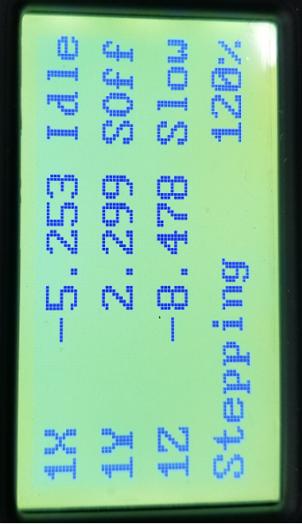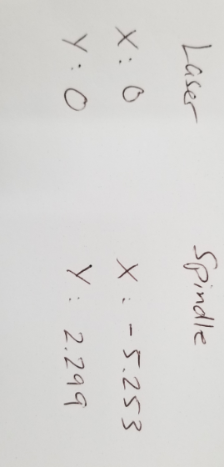

These new numbers can now be added into the work offset of the controller. In order to access this from the main screen, press the menu button. Go down and press OK to enter in 4.Oper Param. Then, go down and press OK to enter 5.Offset. Press OK to enter 1.Public Offset. Change X and Y respectively from 0 to the new numbers written down from the previous step.

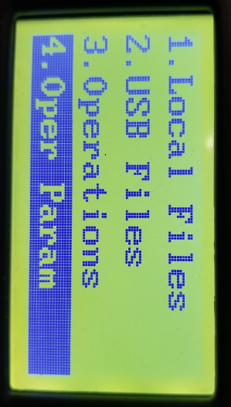
Press the menu button
Press OK

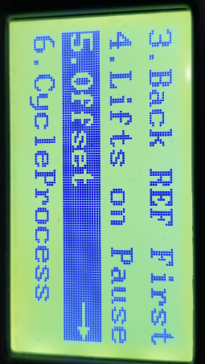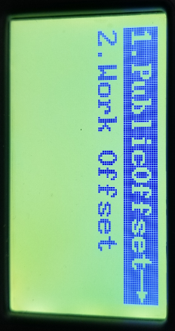
Press OK
Press OK

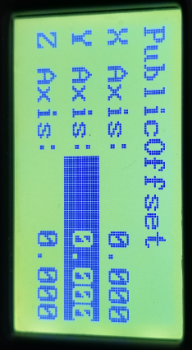
Change the public offset to now read the new values we found from the previous steps.

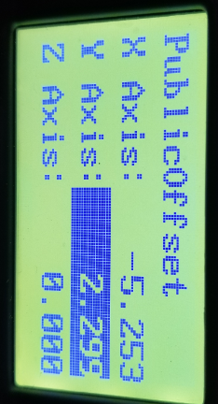

Finally, Press ESC to go all the way back to the main screen and the X and Y coordinates will now read 0 once again.
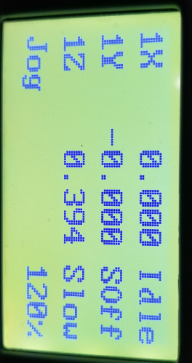

******In order to double check that the offset was set properly, set an origin somewhere on the table of the machine using the laser pointer and then send the machine to that origin using the handheld. The bit in the spindle should land exactly where the origin was set with the laser pointer.

