Installing shroud on 12HP HSD Spindle ATC

Step 1: Remove the old shroud mounted on the spindle plate. Make sure to disconnect the two pneumatic hoses that control movement of the shroud as well as the shroud sensor that indicates that the shroud is up during tool changes, tool touch-offs, and setting the origin.

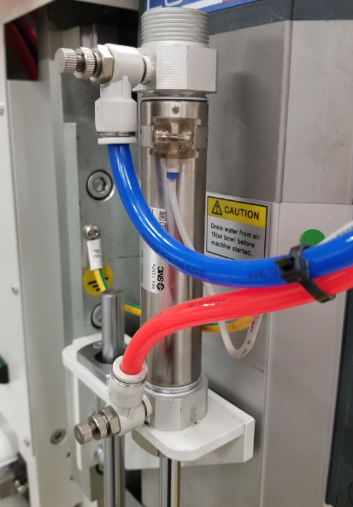

Remove the shroud sensor as well as both pneumatic hoses before removing the whole shroud assembly from the spindle plate.

The two fittings screwed onto the pneumatic cylinder need to be removed as well and placed on the new pneumatic cylinder.

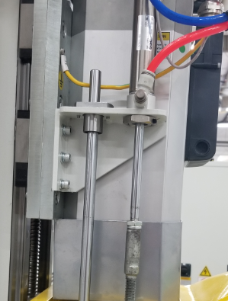 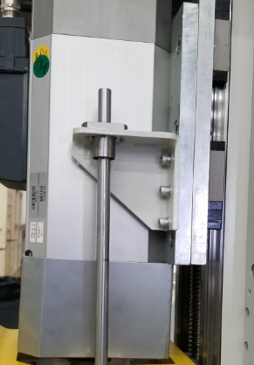

There are a total of 6 bolts (3 on each side) mounting the shroud assembly to the spindle plate.

Step 2: Next, the new shroud assembly must be put together accordingly in order to make sure that everything works properly.

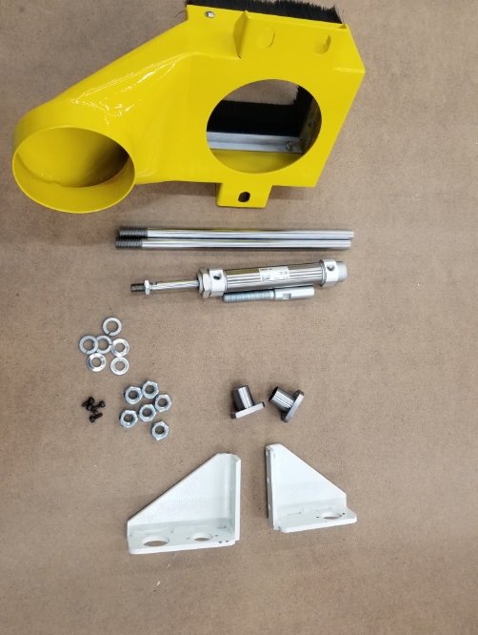

Shroud Guide Rails Pneumatic Cylinder and extension Guide Rail Bearings Shroud Brackets

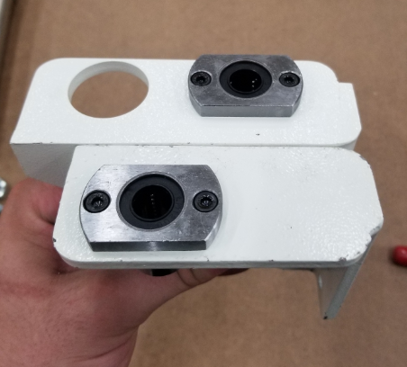

Use M4 screws to attach the guide rail bearings to the shroud brackets as shown.

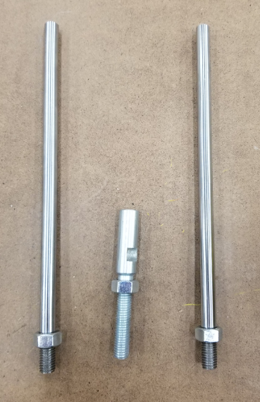

Take 3 M10 nuts and screw them onto the bottom of the 2 guide rails and the pneumatic cylinder extension.

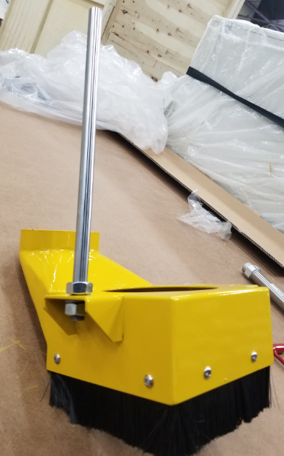

Place one guide rail into the only slot on the left side of the shroud and put a lock washer and nut on the other side and tighten the guide rail to the shroud.

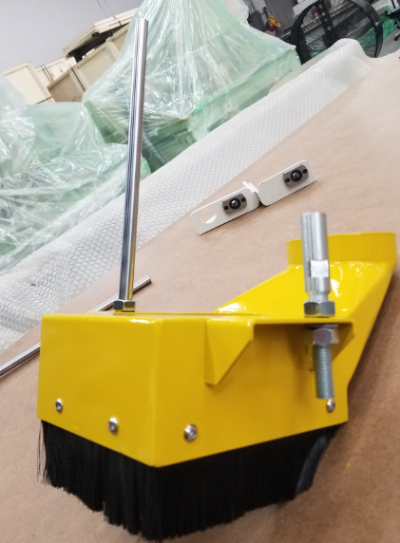

Take the pneumatic cylinder extension and tighten that to the back right slot of the shroud as shown.

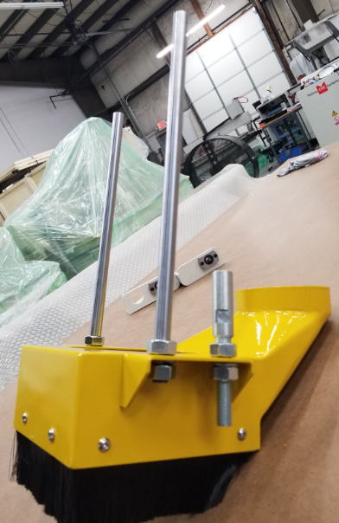

Take the other guide rail and tighten that to the front right slot of the shroud as shown.

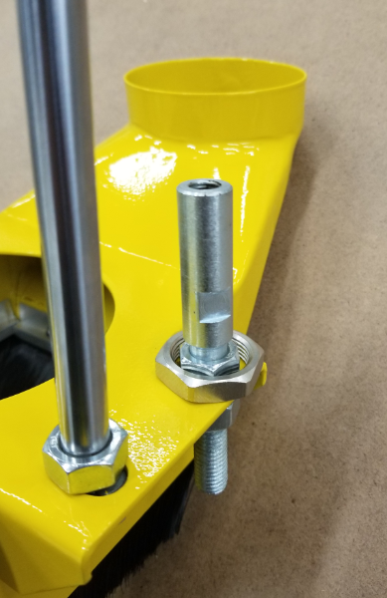

Now take the nut from the pneumatic cylinder and place it over the extension as show.

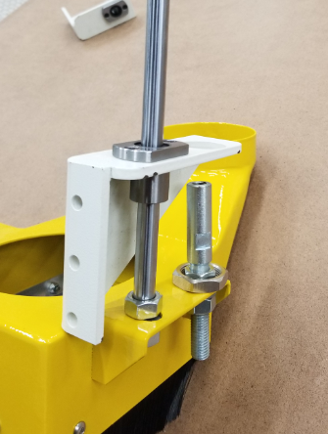

Now take the shroud bracket that has two slots (one for the guide rail and one for the pneumatic cylinder) and place it onto the guide rail as shown.

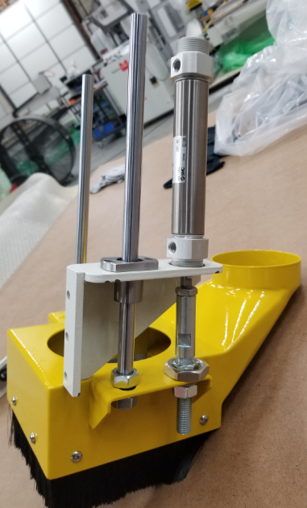

The pneumatic cylinder can now be screwed into the extension as shown.

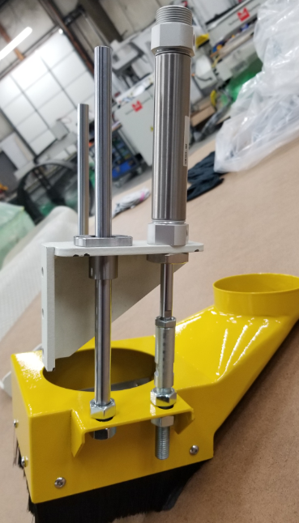

Now take the nut on the pneumatic cylinder and tighten it to the cylinder as shown. The right side of the shroud is now fully assembled.

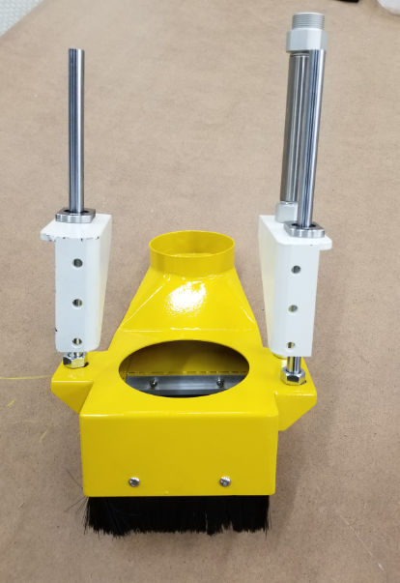

Place the second shroud bracket on the left side of the shroud shown here. The shroud is fully assembled and can be mounted onto the spindle plate.

Step 3: Mount the assembly onto the spindle plate using the 6 bolts that were used for the old assembly and reattach the shroud sensor and hoses back onto the pneumatic cylinder.

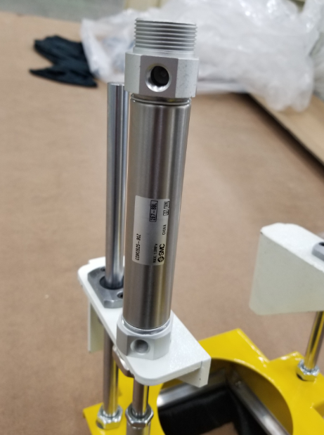

The old fittings from the old pneumatic cylinder can be screwed into the new pneumatic cylinder.

The shroud sensor should be mounted somewhere towards the top of the pneumatic cylinder and can be adjusted until it lights red when the shroud is up.

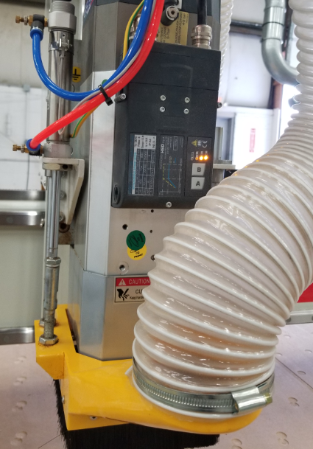

Here we can see that the shroud is down and therefore the sensor will not light up red.

Here we can see that the shroud is up and therefore the sensor will light up red.

