Settings for Techno HD 2 Tabletop 4th Axis Rotary with Gear Box
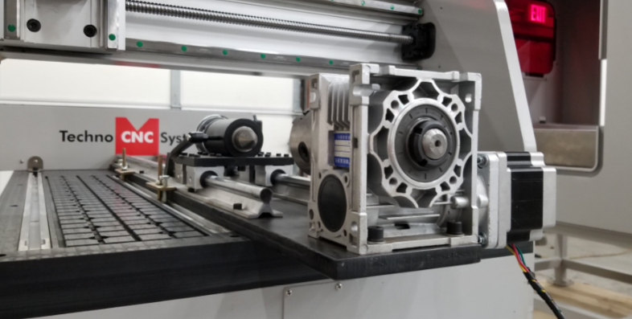

Some settings for the HD 2 tabletop need to be set properly in order for the 4Th Axis rotary with a gear box to run correctly when in operation. Whether a piece of stock is being cut on the rotary or if the rotary is being jogged, it should never exceed 100 in/min. This rotary is known for torque and therefore cannot be ran more than 100 in/min.

RAPID SPEED
The G00 speed, also known as the rapid speed, needs to bet set for 100 in/min maximum. This needs to be done because the gearbox is only rated for up to that speed and it should never be surpassed. When your machine is shipped to you, the G00 speed will be set for 100 in/min, and should not be changed. The G00 speed is important because when the machine is not cutting and needs to move from one point to the next, it will use this speed, which is why it cannot exceed the 100 in/min value.
4. Oper Param
1. G00 Speed
100 in/min (set for 4th Axis Rotary)

JOGGING
The rotary axis should not be jogged more than 100 in/min as well. Always use the SLOW speed on the handheld and make sure it is only set to 100 in/min maximum. If it is set any higher and the rotary axis is engaged, the gearbox will not work properly.
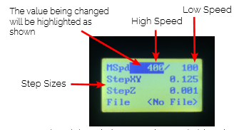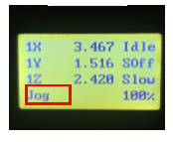

CUTTING
When cutting a file make sure your feed-rate is not set for more than 100 in/min when cutting a piece of stock on the rotary. Again, if it is not set properly the gear box will not work properly. Any CAD/CAM software allows for you to change your feed-rate accordingly and in this case it should never exceed 100 in/min.
